Activity No. 13
Working with Files and Directories in Linux
Course Code: CPE 201A | Program: BSCPE
Course Title: COMPUTER SYSTEM ADMINISTRATION AND TROUBLESHOOTING | Date Performed: October 20, 2026
Section: CPE11S2 | Date Submitted:
Name: Chiara M. Pagaddu | Instructor: Sir Noel Jason Lusung
1. Objective/s:
This activity aims to navigate and manage files and directories using command line interface.
2. Intended Learning Outcome/s:
The students should be able to:
2.1 Demonstrate how to navigate home and system directories
2.2 Demonstrate how to list files and directories.
2.3 Demonstrate how to use globbing to manipulate files and directories.
2.4 Demonstrate how to create, move and delete files and directories.
3. Discussion:
Files and Directories
The Linux filesystem is similar to other operating system’s filesystems in that it contains files and directories. Files contain data such as human-readable text, executable programs, or binary data that is used by the computer.
Directories are used to create organization within the filesystem. Directories can contain files and other directories.
Directory Structure
On a Windows system, the top level of the directory structure is called My Computer. The Linux directory structure, called a filesystem, also has a top level called the root directory (symbolized by the slash /character).

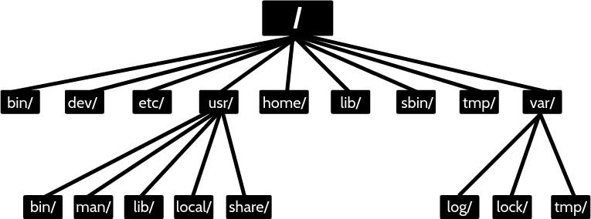

Home Directory
On most Linux distributions there is a directory called home under the root /directory. Under this /home directory there is a directory for each user on the system. When a user opens a shell, they should automatically be placed in their home directory. The user has the full control to create and delete additional files and directories in their home directory. Most other directories in a Linux filesystem are protected with file permissions. The home directory has a special symbol used to represent it, the tilde ~ character.
The directory name is the same as the name of the user. So, a user named sysadmin would have a home directory called /home/sysadmin:
File and Directory Names
File and directory names in Linux can contain lower case and uppercase letters, numbers, spaces and special characters. However, since many special characters have a special meaning in the Linux shell, it is good practice to not use spaces or special characters when naming files or directories. Spaces, for example, need the escape character \ to be entered correctly
Paths

A path is a list of directories separated by the / character. There are two types of paths: absolute and relative. For example, /home/sysadmin is a path to the home directory
- Absolute Paths
Absolute paths allow the user to specify the exact location of a directory. Absolute paths always start at the root directory, and therefore it always begins with the / character.
- Relative Paths
A relative path gives directions to a file relative to the current location in the filesystem. The user must currently be in a directory that contains objects in the path. Relative paths start with the name of a directory.
Special Relative Paths
The single period (.) character always represents the current directory.
Two period (..) characters always represent one directory higher relative to the current directory, sometimes referred to as the parent directory.
4. Resources:
Personal Computer with installed Virtual Box
Ubuntu Server or Desktop virtual machine
5. Procedure:
- Login using your username and password.
- Use terminal emulator application (if you are using desktop version)
- Execute the following commands to navigate files and directories. Copy a screenshot as output after you execute the given command. Create a brief explanation of the command.
Command | Screenshot | Explanation
1. pwd | 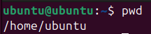
2. cd / | 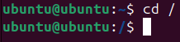
3. pwd | 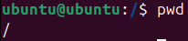
4. cd | 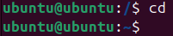
5. pwd | 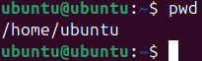
6. cd /home | 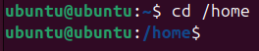
7. pwd | 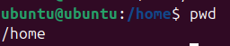
8. cd ~ | 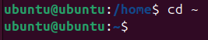
9. pwd | 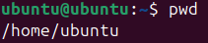
10. echo ~
~sysadmin ~root
~mail ~nobody where sysadmin is your username
11. cd ~root | 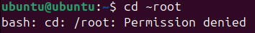
12. cd /usr/bin | 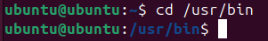
13. pwd | 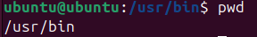
14. cd /usr | 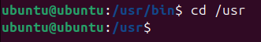
15. type ls | 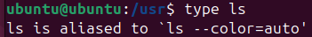
16. pwd | 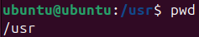
17. cd /usr/share/doc | 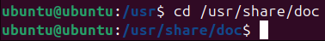
18. pwd | 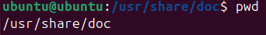
19. cd bash | 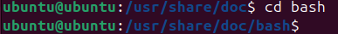
20. pwd
21. cd .. | 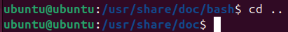
22. pwd | 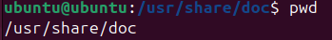
23. cd ../dict | 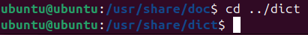
24. pwd | 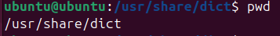
25. cd | 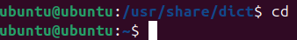
26. ls
27. ls -a | 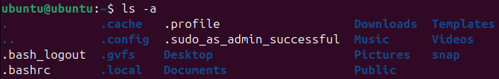
28. ls -l /etc/hosts
29. ls -R /etc/udev | 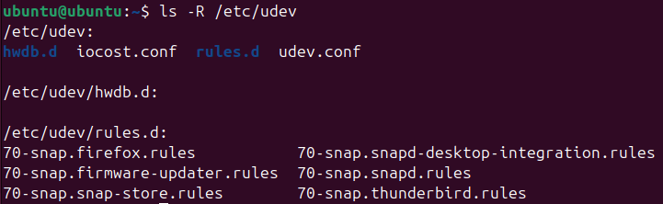
30. ls -d /etc/s* | 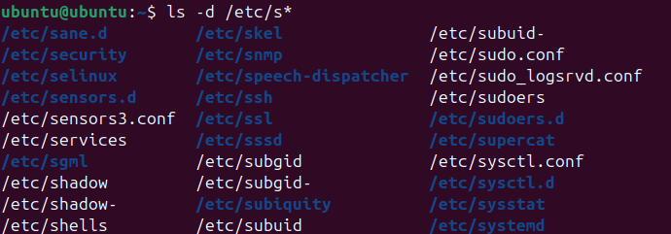
31. ls -d /etc/???? | 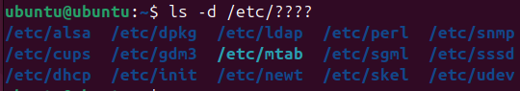
32. ls –d /etc/[abcd]* | 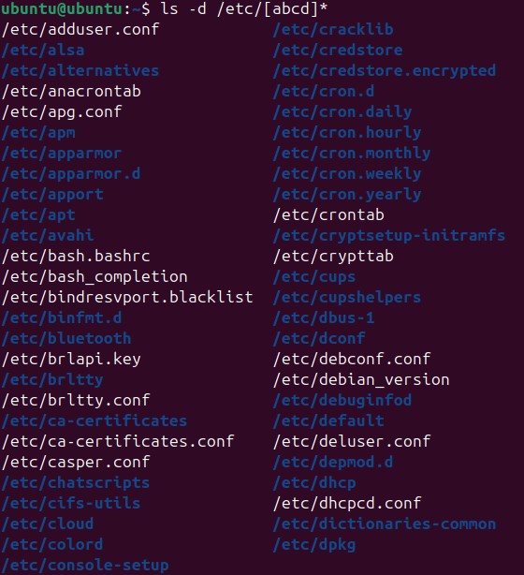

- Execute the following commands to manage files and directories. Copy a screenshot as output after you execute the given command. Create a brief explanation of the command.

Command | Screenshot | Explanation
1. echo *
2. echo D* | 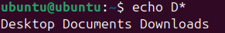
3. echo P* | 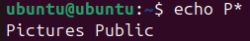
4. echo *s
5. echo D*n*s | 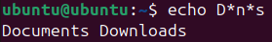
6. echo ?????? | 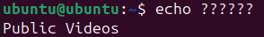
7. echo D???????? | 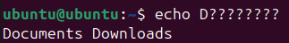
8. echo ?????*s | 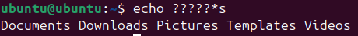
9. echo [DP]* | 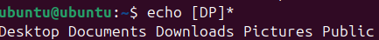
10. echo [!DP]* | 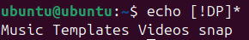
11. echo [D-P]* | 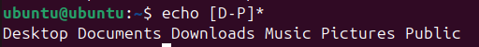
12. echo [!D-P]* | 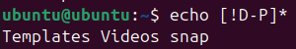
13. ls
14. cp /etc/hosts hosts | 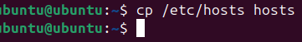
15. ls
16. rm hosts | 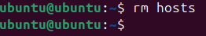
17. ls
18. cp –v /etc/hosts hosts | 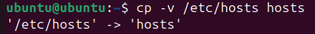
19. ls
20. rm hosts | 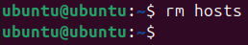
21. ls
22. cp –v /etc/hosts . | 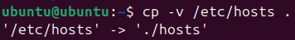
23. ls
24. rm hosts | 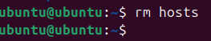
25. ls
26. cd /etc | 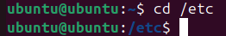
27. ls -l hosts
28. cp –p hosts/home/sysadmin | 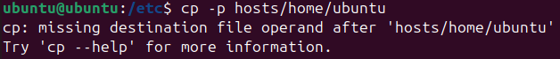
29. cd | 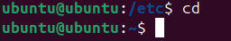
30. ls –l hosts
31. rm hosts  32. cp -p /etc/hosts ~  33. cp hosts newname  34. ls –l hosts newname  35. rm hosts newname | 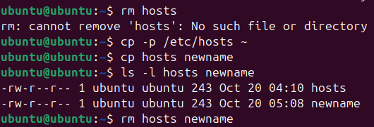
36. mkdir Myetc  37. cp –R /etc/udev Myetc  38. ls –l Myetc  39. ls –lR Myetc | 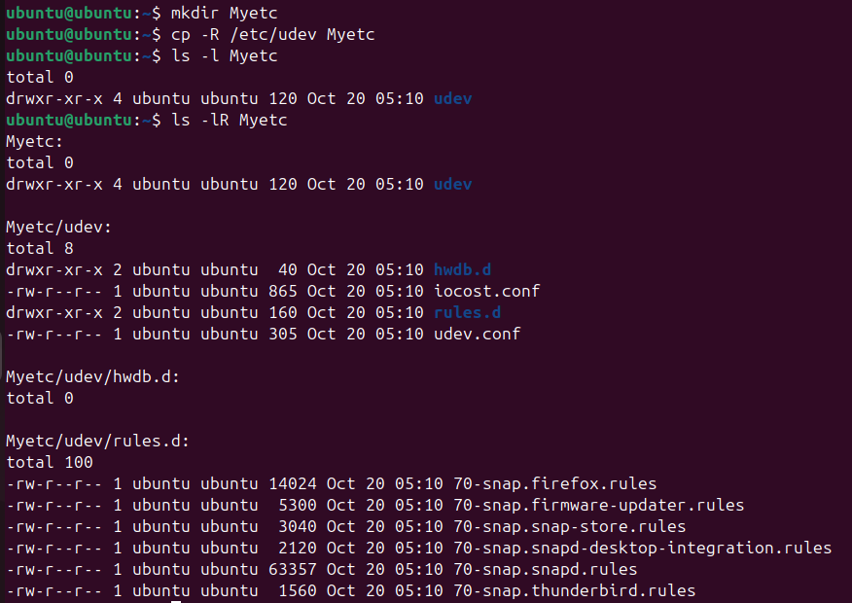
40. ls  41. rm -r Myetc42. ls | 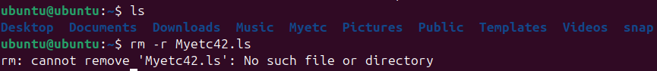
43. touch premove  44. ls  45. mv premove postmove  46. ls  47. rm postmove | 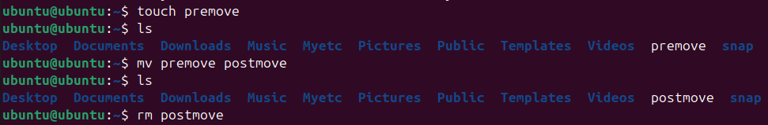

6. Supplementary Activity:
Copy screen shot(s) of the following tasks:
- Create a directory CPE201 in the Documents directory.
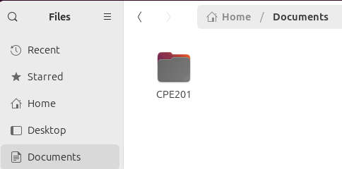
- Create a directory <lastname> and <firstname> under CPE201 directory.
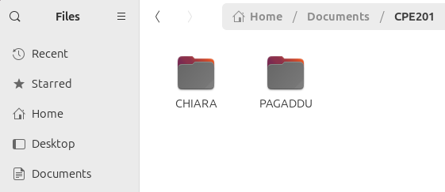
- Create two text files: (1) A.txt and (2) B.txt in the <lastname> directory.
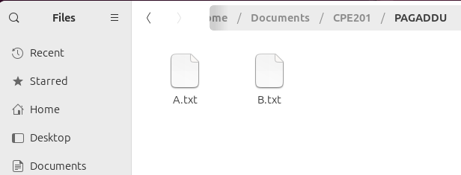
- Copy the content of <lastname> directory to <firstname> directory.
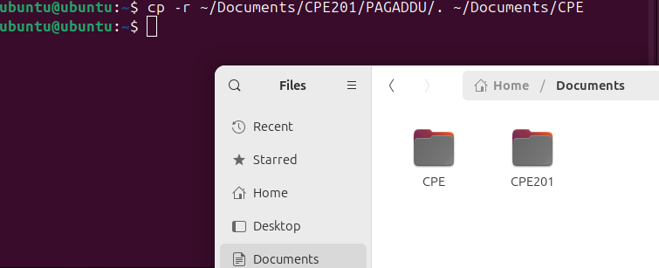
- Delete the content of <lastname> directory.
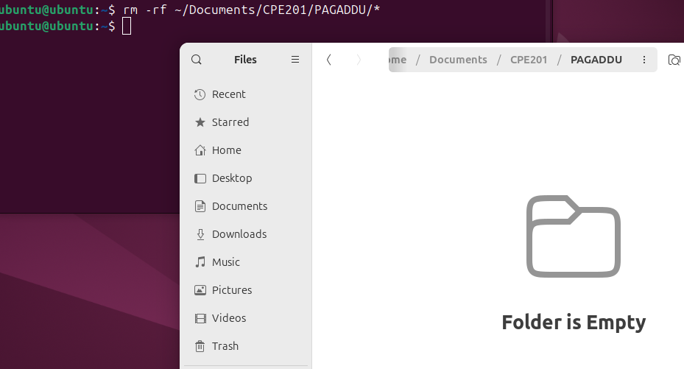
- Create a directory CPE201_backup in the Documents directory.
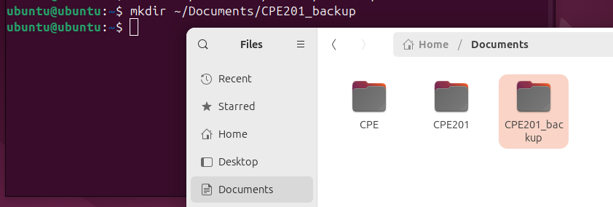
- Copy the content of CPE201 to CPE201_backup directory.
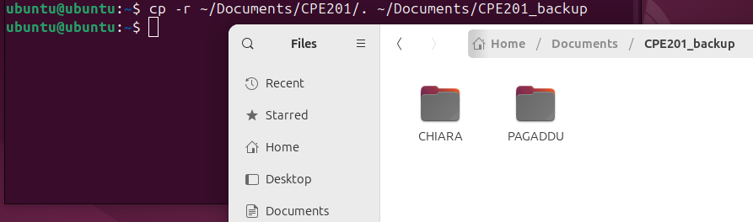
- Remove the CPE201 directory.
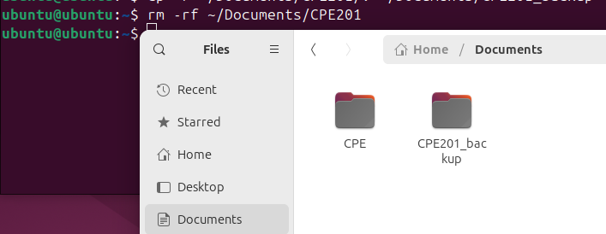

7. Conclusion:
In conclusion, to this laboratory activity

8. Assessment (Rubric for Laboratory Performance):

